Online Appointment Scheduling System

Introduction
The Online Appointment Scheduling System is a web-based application designed to simplify the process of booking and managing appointments. Instead of using manual or paper-based scheduling, this system allows users to conveniently create, view, update, and delete appointment records through a web interface.
The main purpose of the system is to reduce scheduling conflicts, improve data organization, and provide an efficient way to store and manage appointment information. The system is suitable for small offices, clinics, schools, or service providers that need a simple appointment management solution.
The system was developed using HTML, CSS, and JavaScript for the frontend interface and PHP with MySQL for the backend and database management.

Database Design

1.1 Database Overview
The system uses a MySQL database named appointment_system. The database is designed with proper normalization and consists of three related tables: users, services, and appointments. Primary keys and foreign keys are used to maintain data integrity and establish relationships between tables.

1.2 Tables Description

Table 1: users
This table stores information about users who book appointments.
Field Name | Data Type | Description
user_id | INT (Primary Key) | Unique identifier for each user
full_name | VARCHAR | Full name of the user
email | VARCHAR | Email address of the user

Table 2: services
This table stores the list of services available for appointment booking.
Field Name | Data Type | Description
service_id | INT (Primary Key) | Unique identifier for each service
service_name | VARCHAR | Name of the service

Table 3: appointments
This table stores appointment details and links users with services.
Field Name | Data Type | Description
appointment_id | NT (Primary Key) | Unique identifier for each appointment
user_id | INT (Foreign Key) | References users.user_id
service_id | INT (Foreign Key) | References services.service_id
appointment_date | DATE | Scheduled date of the appointment
appointment_time | TIME | Scheduled time of the appointment

1.3 Table Relationships (ER Diagram Description)
- One user can have many appointments (One-to-Many relationship).
- One service can be associated with many appointments (One-to-Many relationship).
- Each appointment belongs to exactly one user and one service.
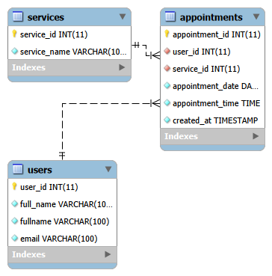
ER Diagram (Text Description)

Web Interface

1.1Key Pages index.php (Main Page)
- Displays the appointment booking form
- Displays a table of existing appointments
- Provides Edit and Delete actions for each appointment

1.2 Core Functionalities
- Create Appointment: Users can enter their name, email, select a service, choose a date and time, and submit the form to create a new appointment.
- View Appointments: All appointments are displayed in a table with the user name, service, date, and time.
- Update Appointment: Users can edit existing appointment details through an update form.
- Delete Appointment: Users can remove appointments from the system using the delete option.

1.3 Core Functionalities
- Create Appointment: Users can enter their name, email, select a service, choose a date and time, and submit the form to create a new appointment.
- View Appointments: All appointments are displayed in a table with the user name, service, date, and time.
- Update Appointment: Users can edit existing appointment details through an update form.
- Delete Appointment: Users can remove appointments from the system using the delete option.

Challenges and Learning

1.1 Challenges Encountered
One of the main challenges encountered during development was handling database relationships and ensuring that foreign keys were correctly implemented. Debugging SQL errors such as undefined columns and variable warnings in PHP was also challenging, especially when joining multiple tables.
Another challenge was ensuring that data displayed on the web interface matched the records stored in the database without errors.

1.2 Learning Outcomes
Through this project, valuable skills were developed in:
- Designing relational databases using MySQL
- Writing SQL queries for CRUD operations
- Integrating PHP with MySQL
- Debugging PHP and SQL errors
- Building a functional and user-friendly web application

Conclusion
The Online Appointment Scheduling System successfully meets the project requirements by integrating database management and web development concepts. It provides a simple yet functional solution for managing appointments and serves as a strong foundation for more advanced systems in the future.

